|  |
| --- |
| Chicago Crimes  Team Pandas  UNC Boot Camp July 2019 |
| Divya TV  Harshavardhan Suresh  Kevin Kao  Ramesh Kalagnanam |



## Chicago Crimes

Contents

Chicago Crimes 2

Objectives 3

• Determine crime counts for each month for selected crime types breaking down the timeline for every five years. 3

• Determine relationships between criminal activity and weather conditions. 3

• Determine relationship between popular attractions and criminal activity. 3

• Use google maps to provide details of safe and unsafe places in Chicago for a user specified timeline. 3

Data preparation 3

# Objectives

## Determine crime counts for each month for selected crime types breaking down the timeline for every five years.

## Determine relationships between criminal activity and weather conditions.

## Determine relationship between popular attractions and criminal activity.

## Use google maps to provide details of safe and unsafe places in Chicago for a user specified timeline.

# Data preparation

#### Chicago criminal activity Dataset

##### Dataset

This dataset reflects reported incidents of crime (with the exception of murders where data exists for each victim) that occurred in the City of Chicago from 2001 to present, minus the most recent seven days. Data is extracted from the Chicago Police Department's CLEAR (Citizen Law Enforcement Analysis and Reporting) system.

#### Data description:

Number of records or unique cases:

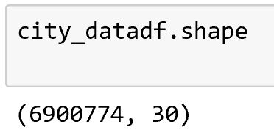

#### Chicago weather conditions Dataset

(Kevin to fill weather dataset details, how he got it, what did he do with it)

#### Use google maps to provide details of safe and unsafe places in Chicago for a user specified timeline.

Safe and Unsafe areas of Chicago based on crime type- Assault between start_date = '07-01-2002'

end_date = '04-01-2019'

Part1: Data Cleanse

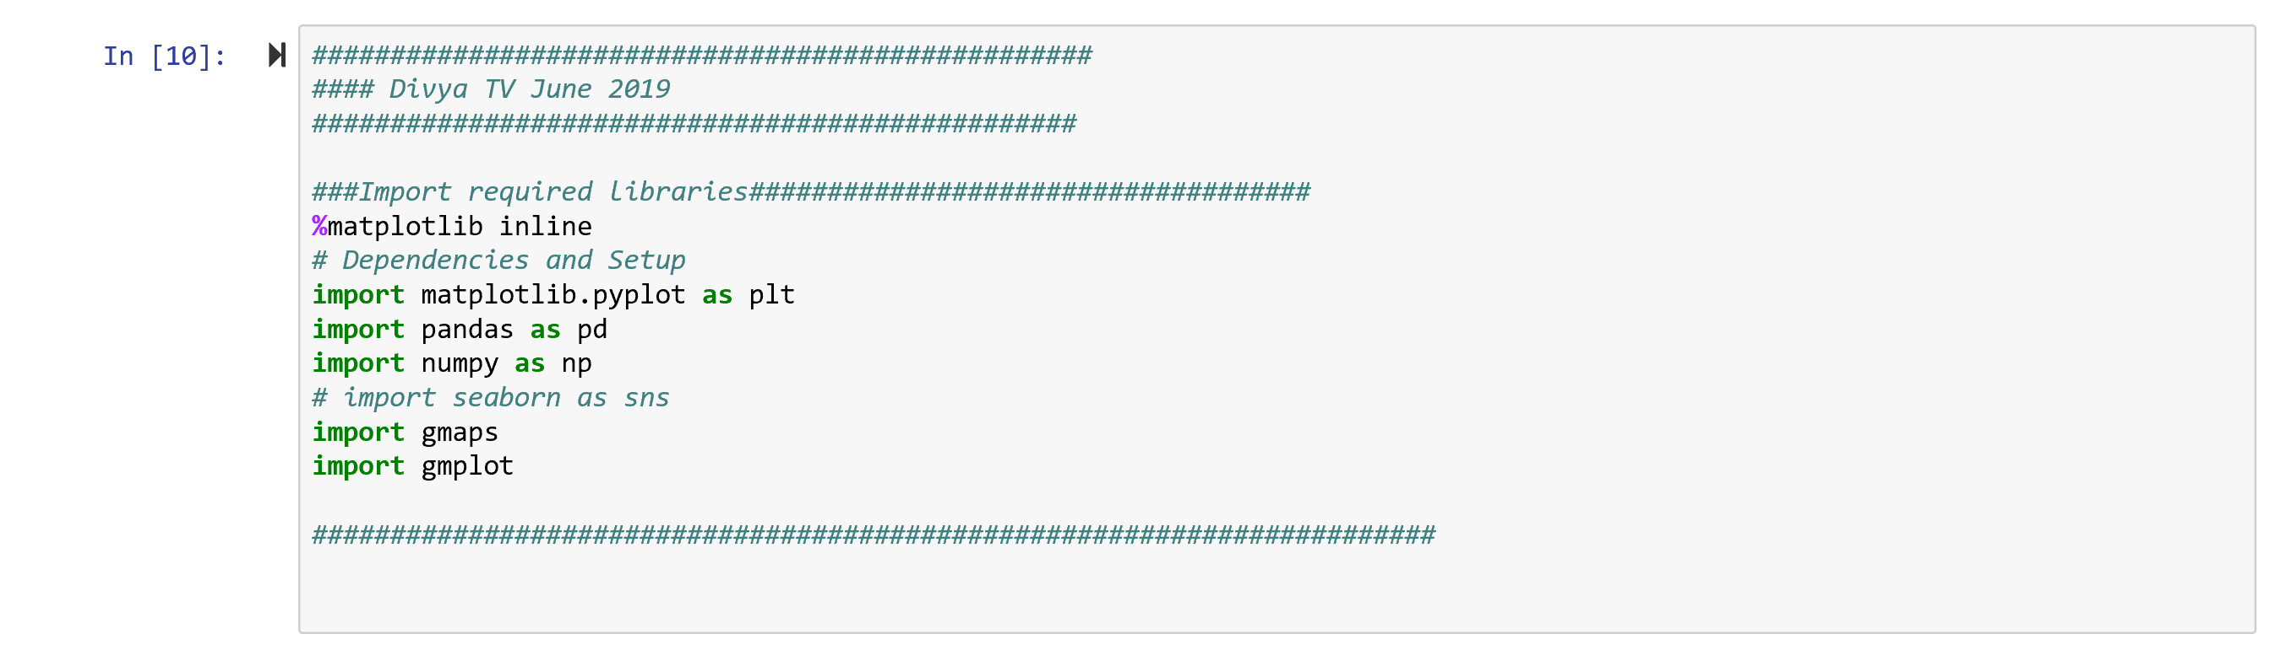

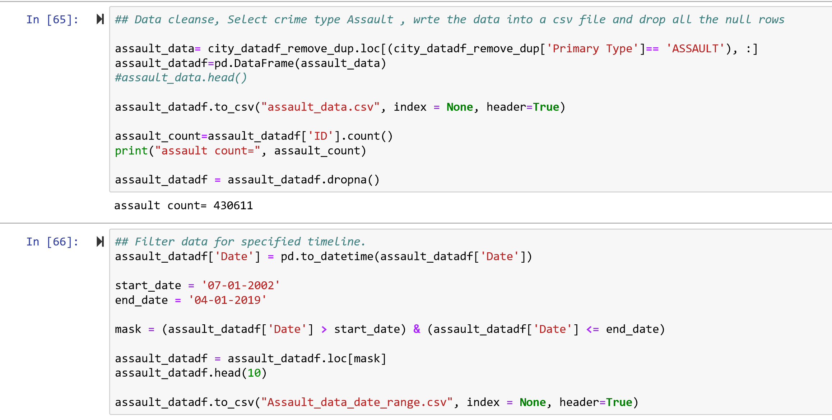

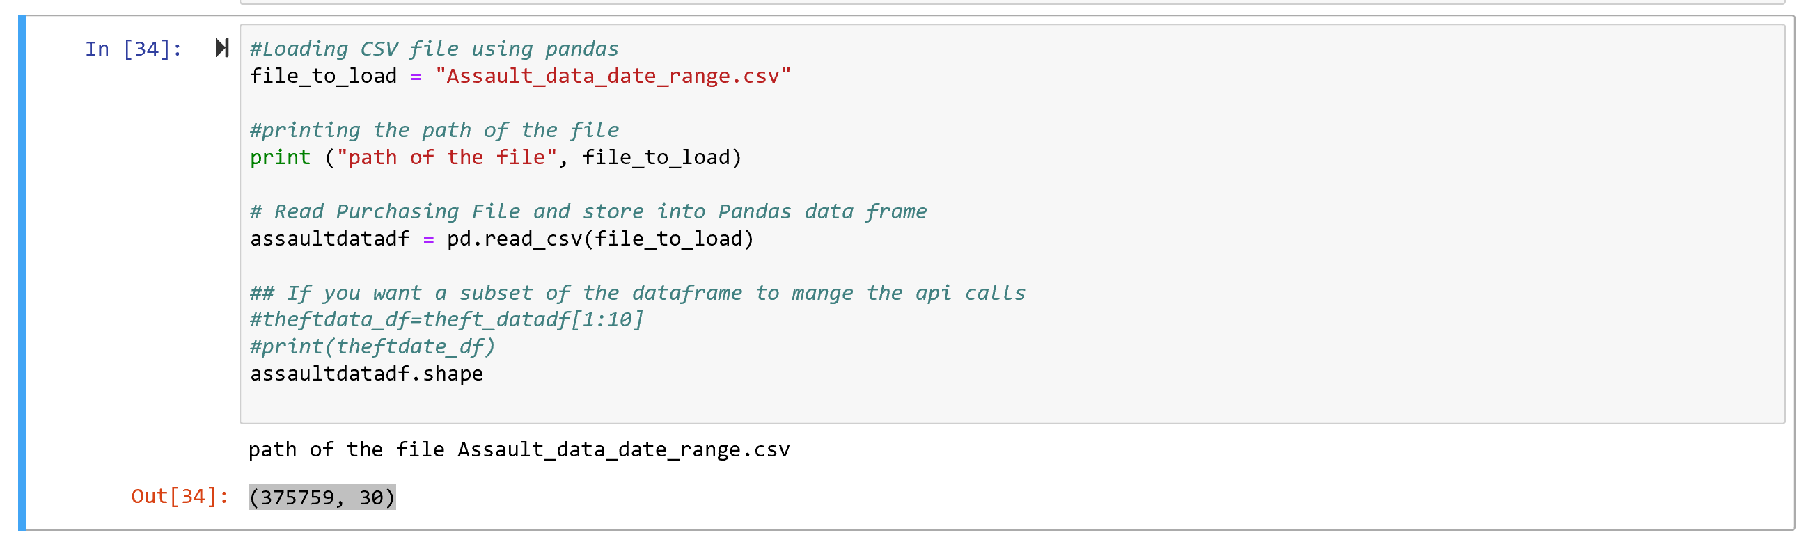

Part2: **Visualization**

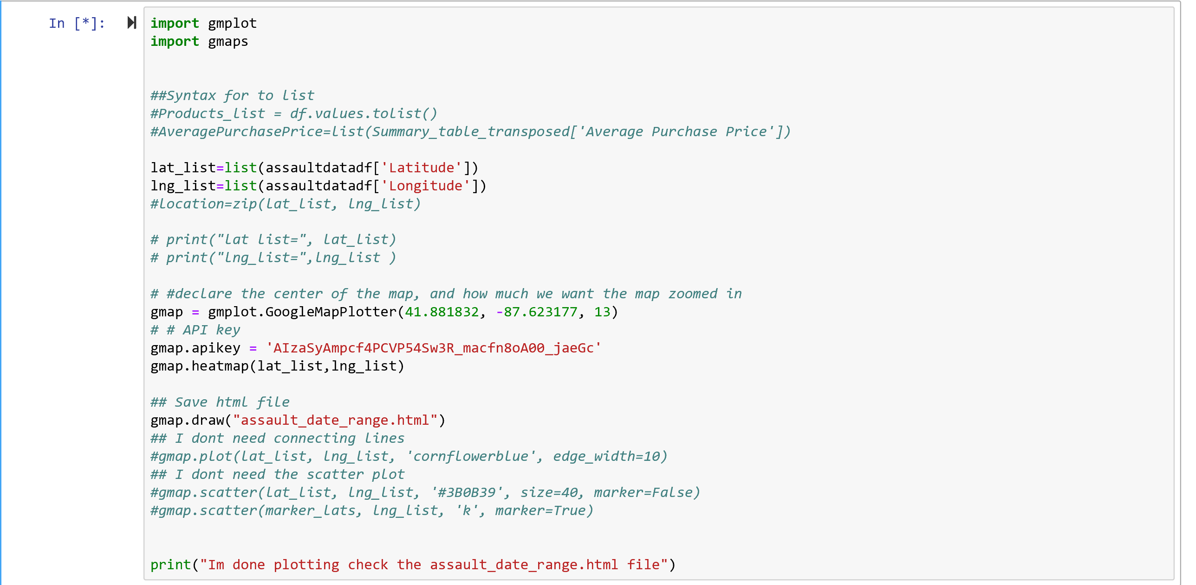

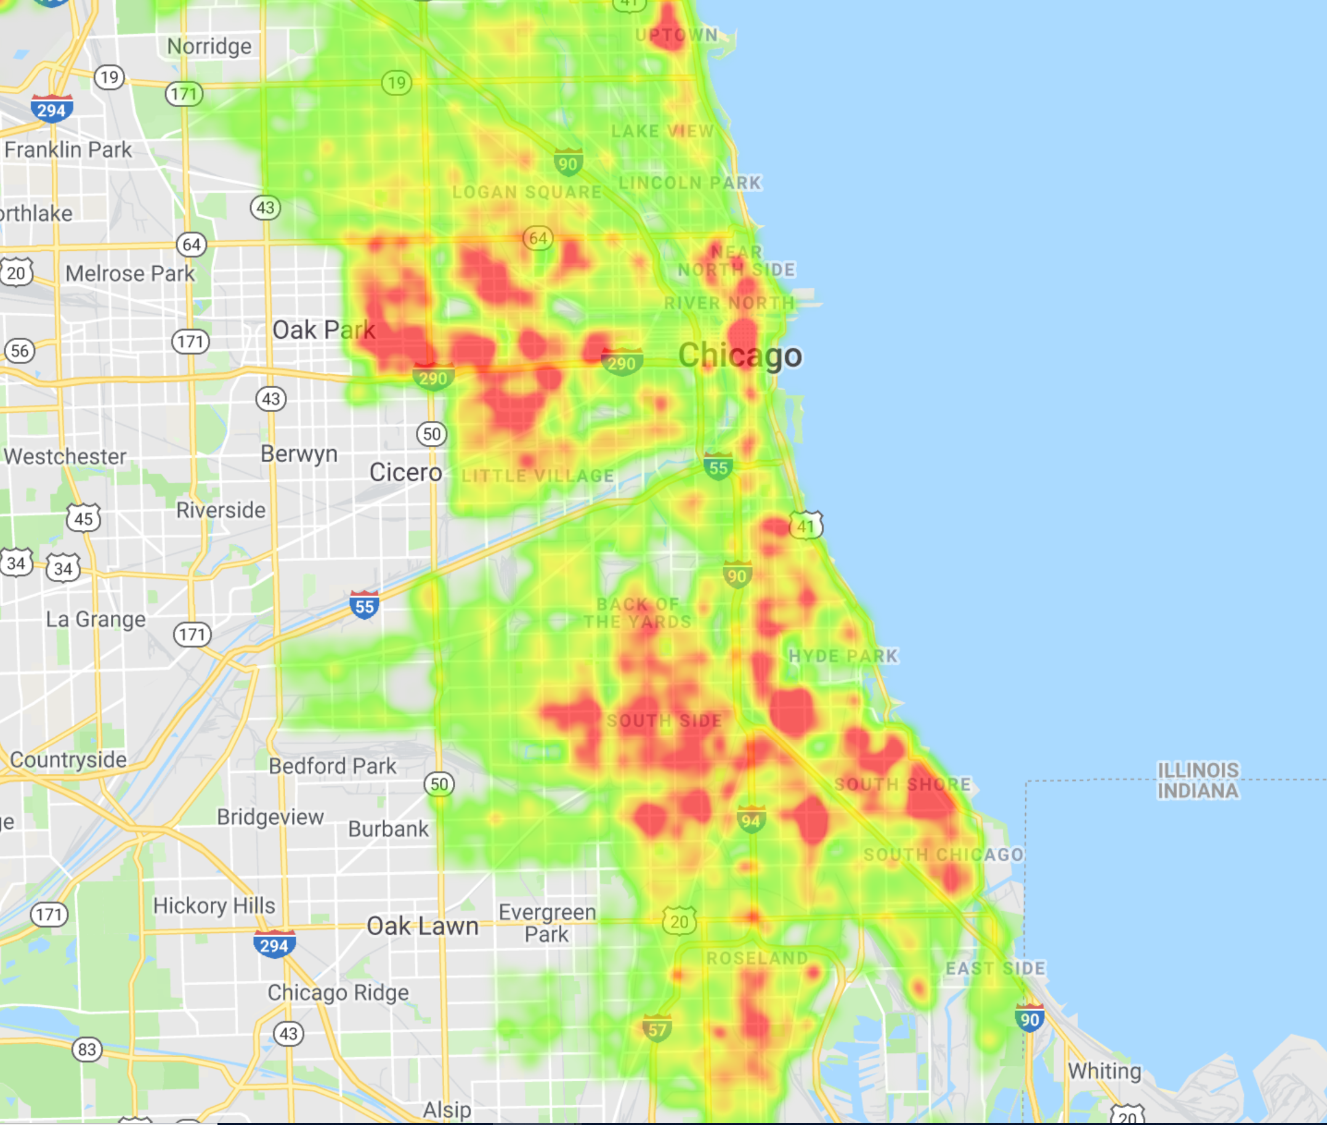

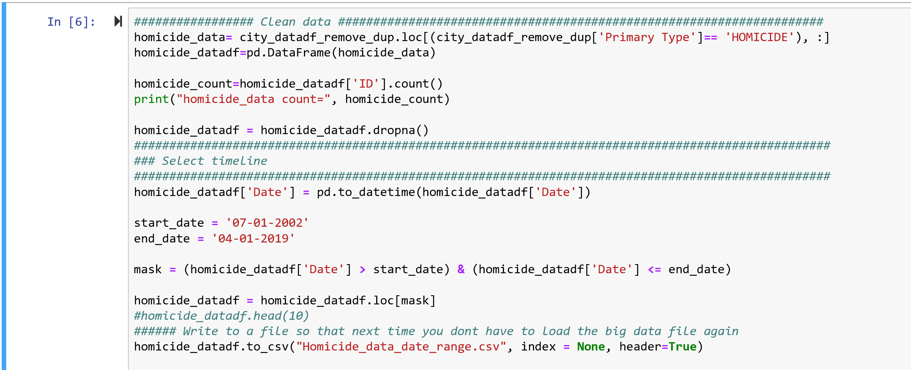

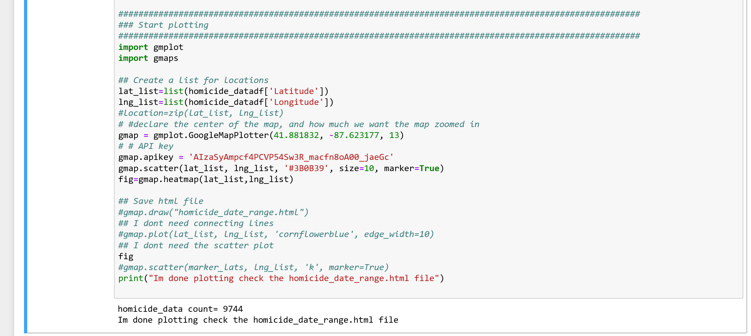

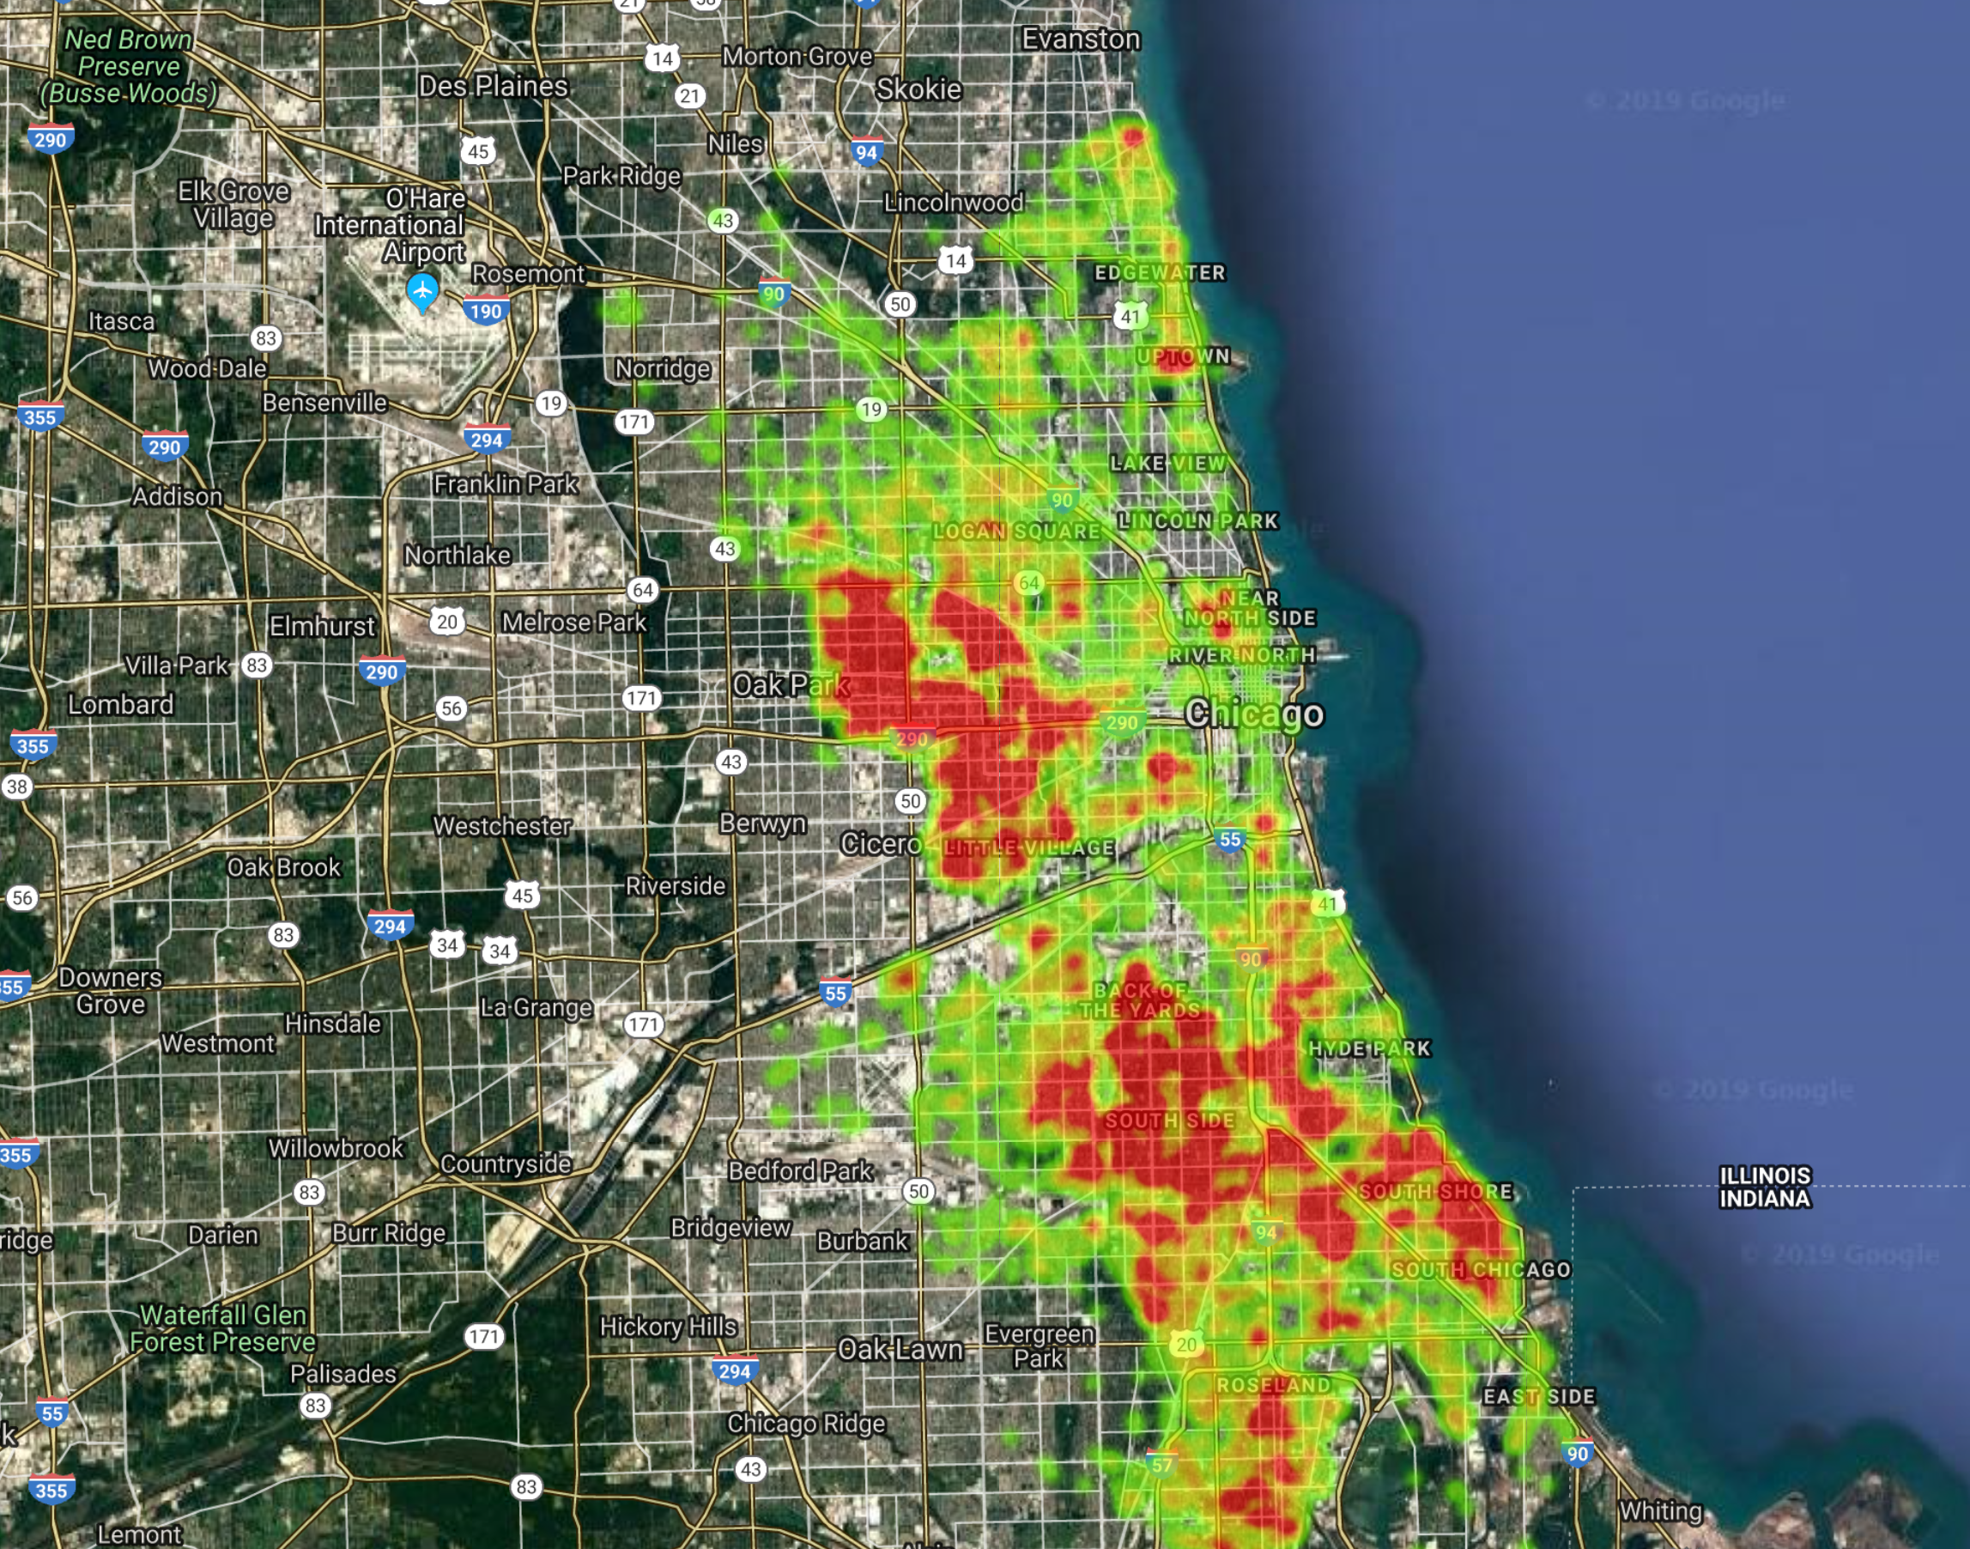

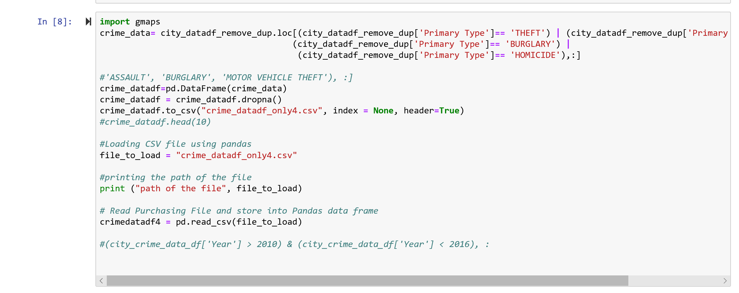

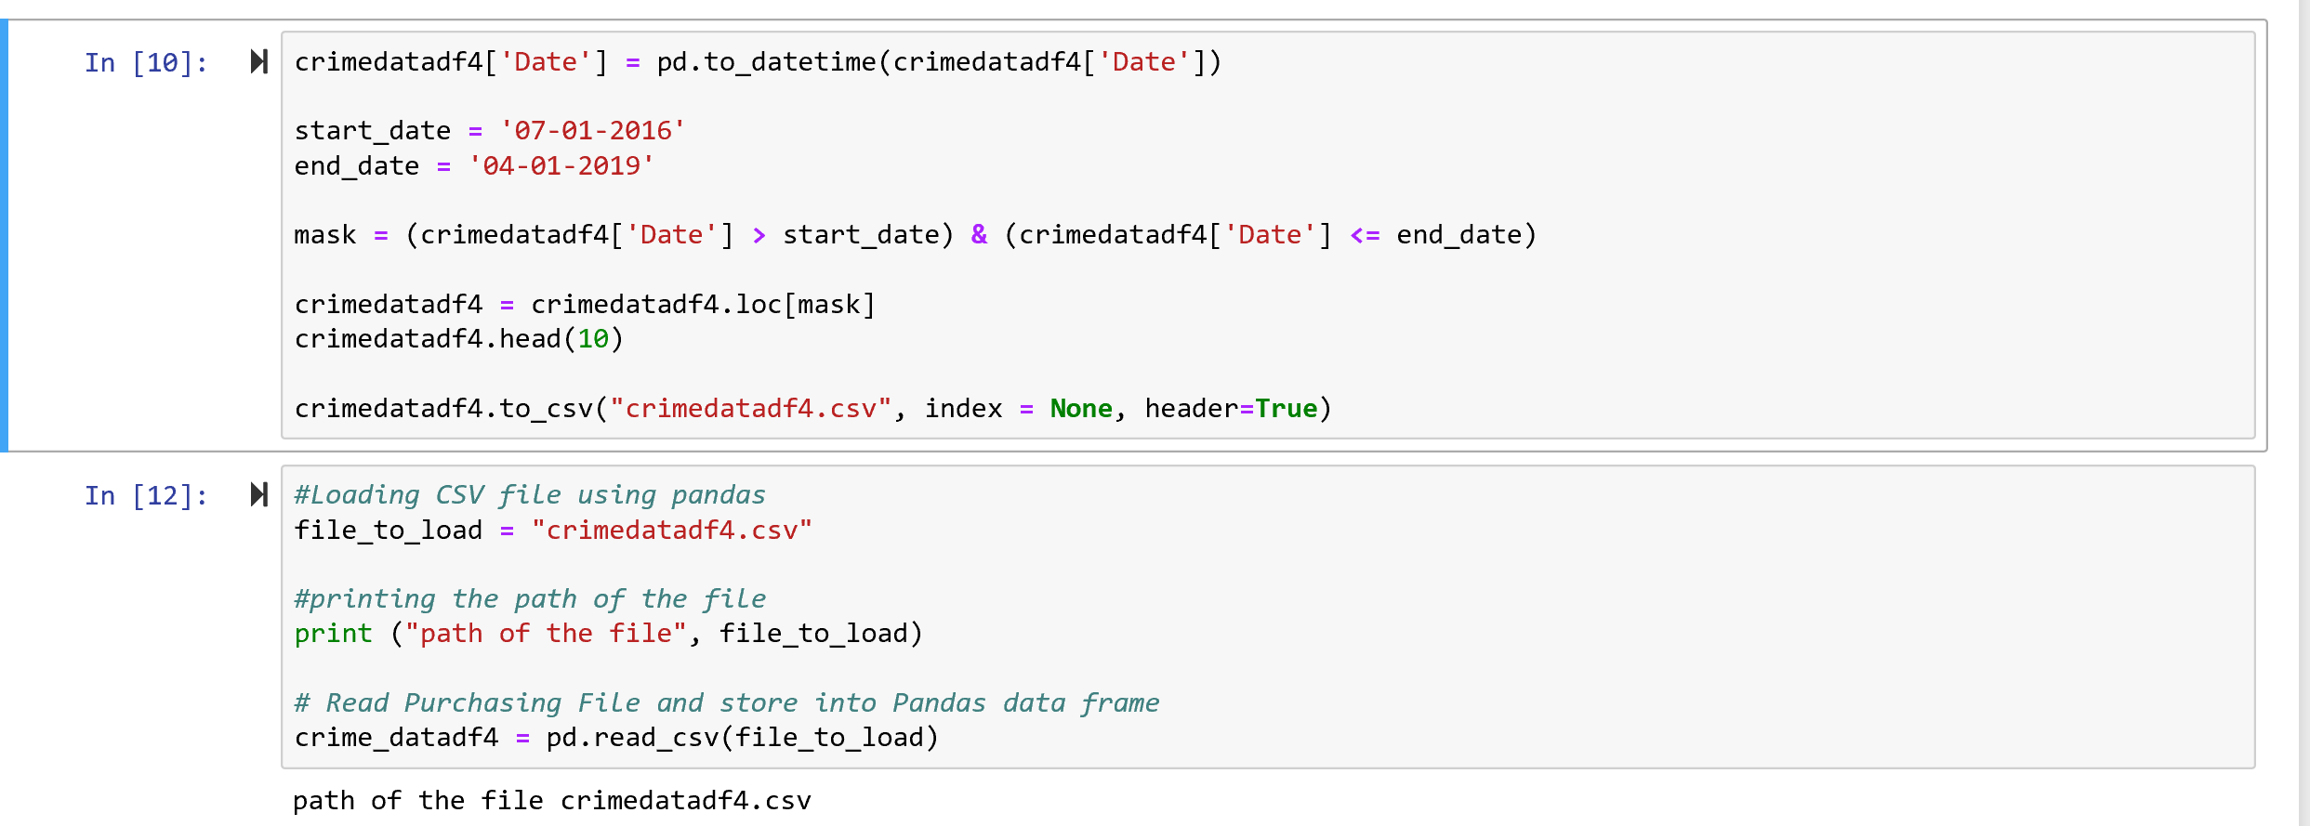

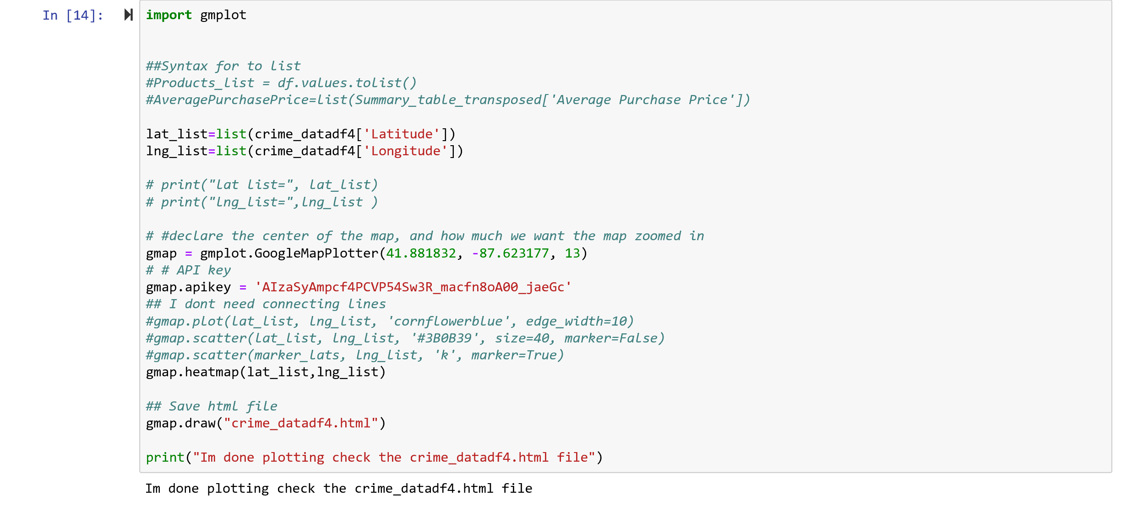

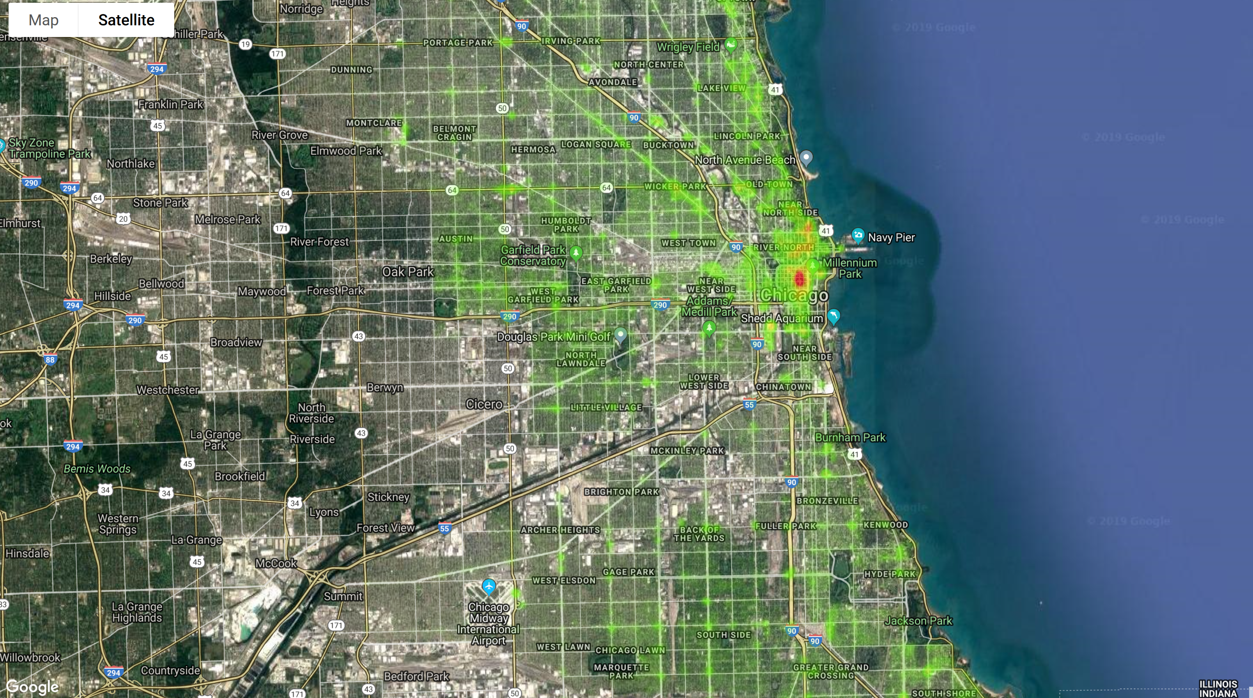

The presentation requirements for Project 1 are as follows.

Your presentation must:

* [ ] Be at least 8-10 min. long

* [ ] Describe the core message or hypothesis for your project.

* [ ] Describe the questions you and your group found interesting, and what motivated you to answer them

* [ ] Summarize where and how you found the data you used to answer these questions

* [ ] Describe the data exploration and cleanup process (accompanied by your Jupyter Notebook)

* [ ] Describe the analysis process (accompanied by your Jupyter Notebook)

* [ ] Summarize your conclusions. This should include a numerical summary (i.e., what data did your analysis yield), as well as visualizations of that summary (plots of the final analysis data)

* [ ] Discuss the implications of your findings. This is where you get to have an open-ended discussion about what your findings "mean".

* [ ] Tell a good story! Storytelling through data analysis is no different than in literature. Find your narrative and use your analysis and visualization skills to highlight conflict and resolution in your data.